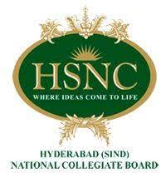 

Principal

Secretary

President

**IQAC**

**CDC**

Office

Examination

Faculty

Members

Registrar

Vice Principal

Administration

Academics

Board of trustees